**2 PCS Islamic Photo Frames**

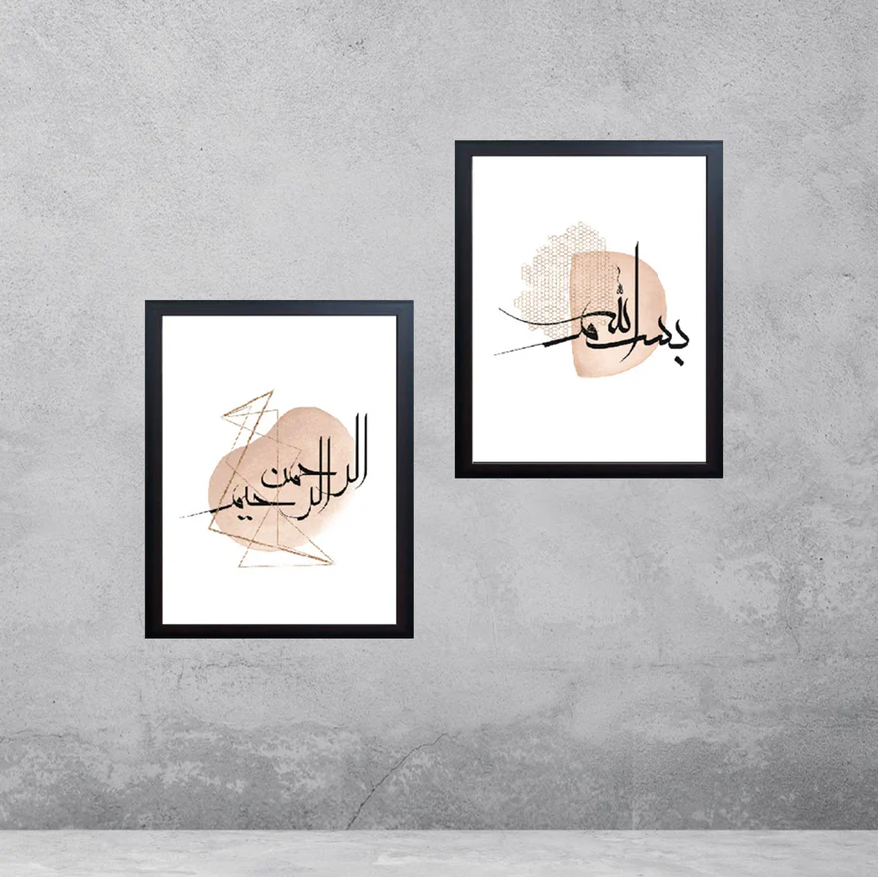The 2 PCS Islamic Photo Frames offer a stylish and meaningful way to display cherished memories or Islamic artwork, bringing a touch of spirituality and elegance to any space. These frames are designed with intricate Islamic motifs, such as geometric patterns, Arabic calligraphy, or Quranic verses, which are often meticulously etched or printed onto the frame’s surface. Made from high-quality materials like wood, metal, or resin, the frames are durable yet lightweight, perfect for placing on walls, shelves, or mantels. Whether showcasing family photos, religious texts, or decorative art, these frames add a sense of serenity and beauty to living rooms, bedrooms, or prayer spaces, reflecting both faith and culture in a modern and sophisticated way. The set of two frames also provides the flexibility to display multiple images or create a cohesive gallery of Islamic-inspired artwork in your home.